Chef Booking Project

1. This is ths signup page where a new user can register first time filling the personal details and if the user already have account you can login directly .



1. This is the login page where user can login by filling the personal information .



1. This is the reset password page.



1. For chef : signup page

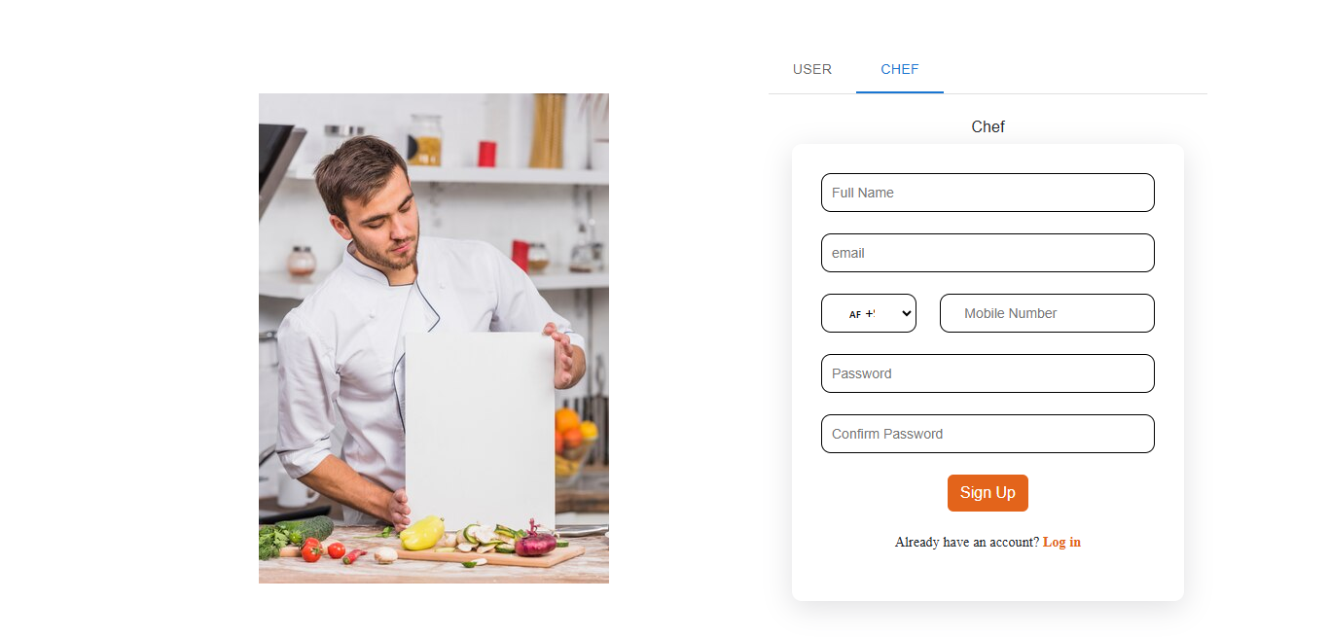

1. Login Page :

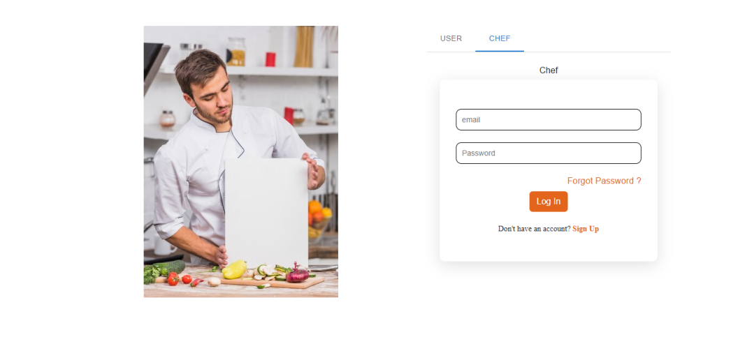

3. Reset Password :

